|  |
| --- |
| EPAM Systems, RD Dep. |
| Data Warehouse Architecture |

|  |  |  |  |  |  |
| --- | --- | --- | --- | --- | --- |
| REVISION HISTORY | | | | | |
| Ver. | Description of Change | Author | Date | Approved | |
| Name | Effective Date |
| 1.0 | Initial status | Arina Marchenko | 09-11-2017 |  |  |

Contents

Analytical task 3

# Analytical task

* 3NF layer of Data Warehouse for my business.

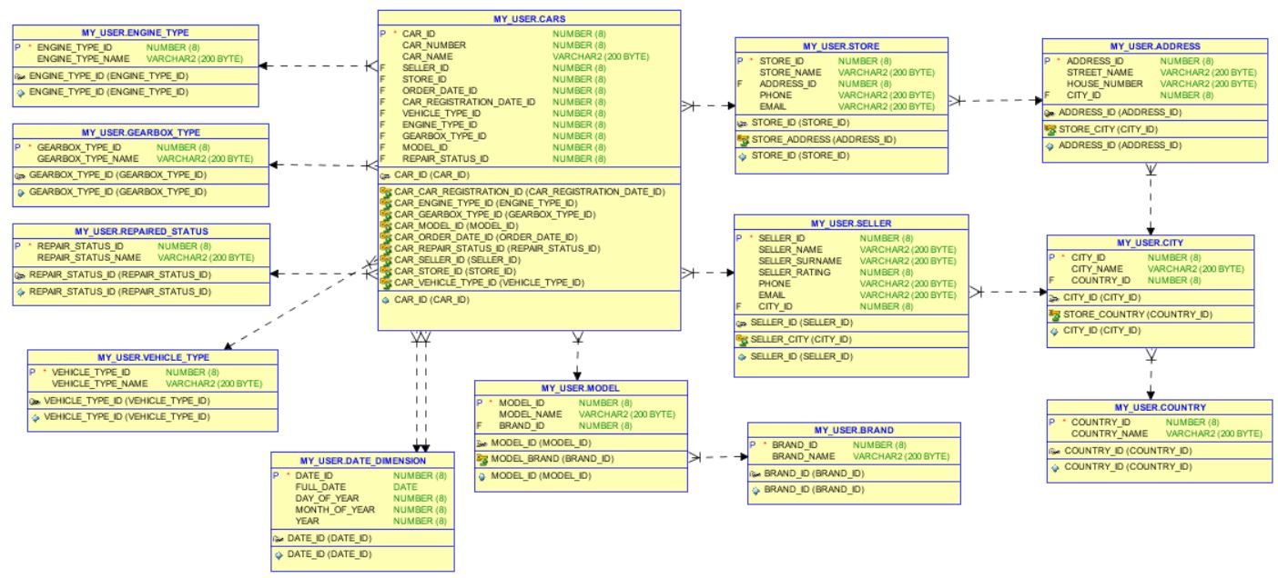

Dimensional Model